1. Sea Level Change

* Mean Sea Level is an average surface level of one or more coastal bodies of water from which heights can be measured. In this dataset, the mean sea level is measured in 24 different coaster and ocean around the world which data will obtained by four satellite altimeters – TOPEX/Poseidon, Jason-1, Jason-2, and Jason-3 – which have monitored the same surfaces since 1992.
* In world change: Graph below is mean sea levels changing in worlds obtained by different sattelites.
  + In scope of a year, there is several variability of mean sea level changing. From the graph, we can easily to catch the rules that, the changing will tend to increase from June to October or November and decrease from November to June next year.
  + Almost time before 2002, the mean sea level changing average was less than 0. It means that the sea level tended to reduce at the specific time compared with pass. But based on the grow up of the line in graph, the gap between changing in sea level between measuring time was smaller and tend to higher than 0. And the common situation of sea level was changing into from negative changing into positive changing.
  + After 2002, there is no recording left that the changing of mean sea levels is below 0. Despite we has some period of time the changing is decreased but overall the trend of changing is still decrease. And compare between 2002 and 2024, the changing has a big gap untill more than 100mm.
  + In some recent years, we can consider a strong increase of mean sea levels.

* Trend in Changing Sea Level: To show the trend of changing in mean sea level per year (means average changing of mean sea levels), the dataset provided the trend of mean sea level change. Average the changing mean sea level is 3.14. From data, average changing trend of each ocean is from 2.23 upto 4.78, in there, most of ocean and coastal are up to 3 which has approximate and has a big changing compared with mean sea level change of worlds.

[The two main factors causing Global mean sea level rise the added water from melting land-based ice sheets and glaciers and the expansion of seawater as it warms.](https://sealevel.nasa.gov/understanding-sea-level/key-indicators/global-mean-sea-level/) Besides that, the rapid growth rate of urbanization and industrilization such as appearing of roads, bridges, subways, water supplies, oil and gas wells, power plants,... By two graphs, there is a big amount of

1. CO2 Concentrations:

Below graph is the concentrations of CO2 into atmospheric yearly. We can observe a huge increasing trend of CO2 concentrations parts average per years. A big gap can be viewed of CO2 concentrations average between 1960s and 2020s, from 320ppm up to 426ppm now.

The graphs below show the development segment of CO2 concentraions over years, which can lead us to know that how much the CO2 concentrations into atmospheric is developed? And based into the graph, we can see there is some period of time that the CO2 concentrations is decreased such as in 1960s or early 2000s. But the increase of this rate is significantly such as from 2022 to 2023 is up to 70% or from 2015 to 2016 is approximate 80%.

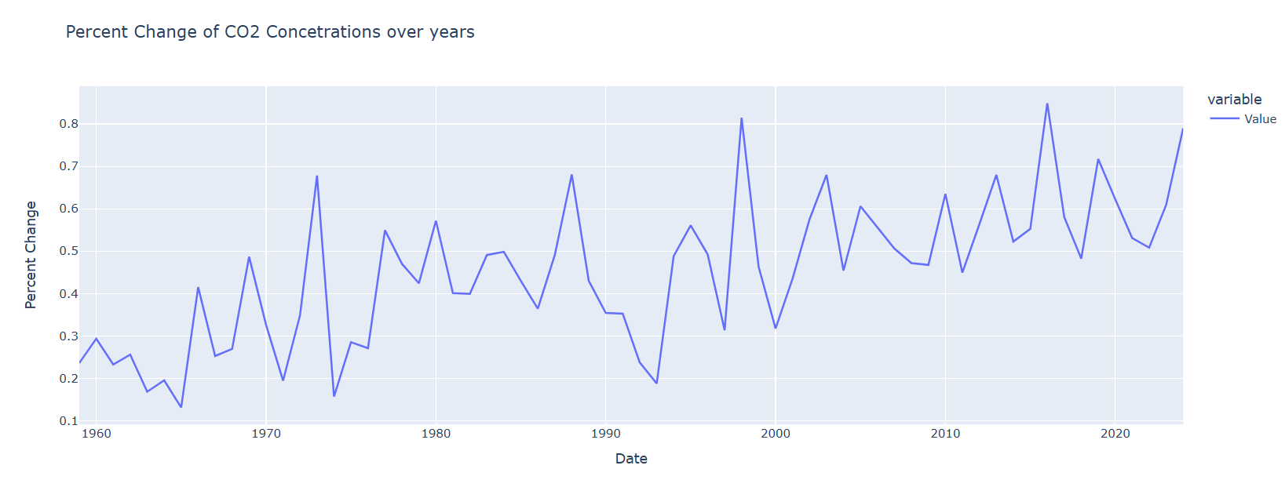

The develop of the fossil fuels that people are burning for energy has a big influnces into why CO2 concentrations has so much high. Fossil fuels like coal and oil contain carbon that plants pulled out of the atmosphere through photosynthesis over many millions of years. By the numbers from middle of 20th century, emissions from burning fossil fuels have increased every decade, from close to 11 billion tons of carbon dioxide per year in the 1960s to an estimated 36.6 billion tons in 2023 according to the Global Carbon Budget 2023. Basically, Carbon Dioxide has an important roles of greenhouse gasses to absorb heat radiating from the Earth’s surface and re-release it in all directions—including back toward Earth’s surface, so as to to keep the average global surface temperature above freezing tempearture. Besides that, it’s important source to provided H+ to ocean which is needed for many species. But by lots of actions of people nows has released so much CO2, so that CO2 concentrations to atmospheric has growp up so much. It’s will directly caused to warm Earth’s temperature during ice age cycles over the past million years. And by small step by step, the tempearature has a small increasing by time. From this, it’s will cause bad consequences to many weather situations such as global warming, climate change by the temperature is higher, the weather is irregular and can caused lots of disaster, sea level higher by melting ice,...